**What do we need to know for the flight?**

* *How do astronauts go to the bathroom? Do we need toilet paper?*
* Do we need to take oxygen and nitrogen to mix our “air”? Any other gases needed?
* Should we “mix” our water?
* We need to filter carbon dioxide from the ship atmosphere.
* How much “air” does an adult human consume per day? 7-8 liters per minute 11,000 liters per day
* How much water does an adult consume per day? 3 liters.
* How much does an adult human pee per day?
* How much does an adult human pee per day?
* Can we take a greenhouse as a source of fresh food and oxygen?

**What do we need to know to colonize?**

**What we need to take with us for the flight**

* Water (how much???)
* Oxygen (mix it in flight??)
* Food(In what form? Freeze Dried?)
* Solar Panels
* Medicines (various medicines)
* Batteries

**What we need to take with us to colonize**

* Batteries
* Vehicles

**Who do we need to take with us?**

* ***Doctor(Surgeons, Nurses, Pediatricians, Cardiologists, Internal Medicine, Psychiatrists, Ophthalmologists, Neurologists, Pulmonologists, Anesthesiologists)
* Engineers (Aerospace, Civil, Environmental, Mining, Electrical)
* Scientists (Geologists, Physicists, Botanists, Mars Climatologist,)
* Skills (Mechanics)

**How long will the flight take, how much fuel? What type of fuel**

As the Shuttle accelerates, the main engines burn a half-million gallons of liquid propellant provided by the large, orange external fuel tank. The main engines burn **liquid hydrogen** -- the second coldest liquid on Earth at minus 423 degrees Fahrenheit (minus 252.8 degrees Celsius) -- and liquid **oxygen**

**39 days (aprox)**

**-Farthest 250 million miles**

**-Average 140 million miles**

**-Farthest approach: 6,944 hours (289 days)**

**-On average: 3,888 hours (162 days)**

**Current Nasa timetable for manned mission to mars: 2035 (as of 9/13/2015)**

**-light-speed 286,000 miles/hour**

**Orion Spacecraft main components**

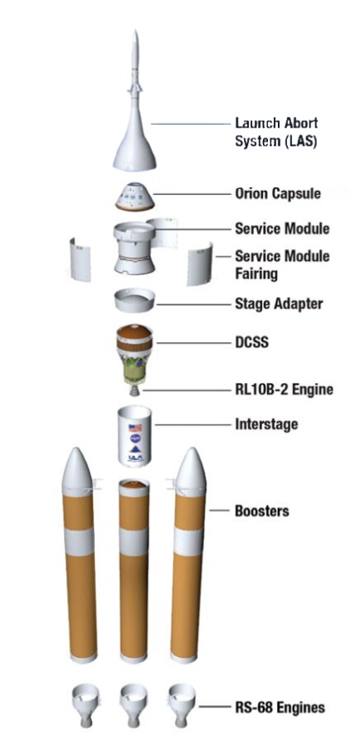

**Launch Abort System**

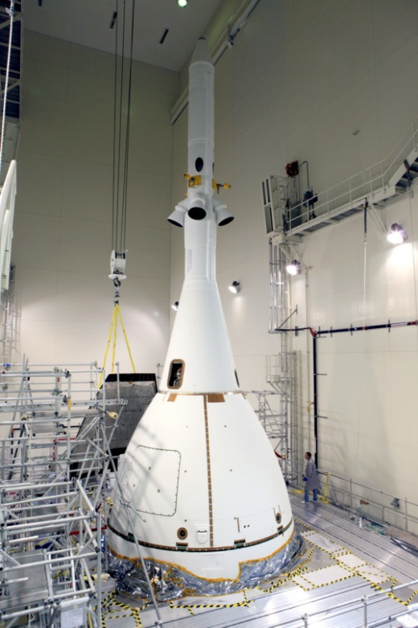

**Crew module (aka the washing machine)**

 As projected, the CM will be 5.02 meters (16 ft 6 in) in diameter and 3.3 meters (10 ft 10 in) in length,[[36]](https://en.wikipedia.org/wiki/Orion_(spacecraft)#cite_note-36) with a mass of about 8.5 metric tons (19,000 lb).

**Service Moduel components with pictures**

